Traffic Simulation Assignment Report
Assignment Number: 1
Name: Hiten Mulmi
Roll Number: 45
1. Summary of Work
This project presents a real-time traffic simulation of a four-way intersection developed using C++ and the SDL3 graphics library. The goal of the simulation is to model realistic traffic behavior by incorporating vehicle movement physics, traffic signal control, and lane-based constraints. The system supports dynamic vehicle spawning, smooth acceleration and deceleration, collision avoidance, and turning movements implemented through parametric curves. A distinctive aspect of the simulation is its asymmetric road design, with special emphasis on Road A (North). In this road, only the central lane is designated for incoming traffic, while the outer lanes function as outgoing lanes. This configuration introduces non-uniform traffic flow and adds realism to the model.
Additionally, the project includes an adaptive traffic light system that adjusts signal timing based on real-time congestion levels. Lane densities are continuously monitored, allowing the system to prioritize heavily congested lanes and improve overall traffic throughput.
2. Data structure used
Several data structures were nested to manage the simulation efficiently and maintain code readability.
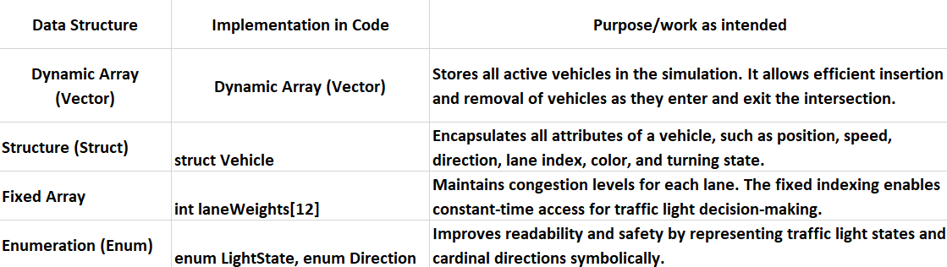

3. Implementation
The following core functions utilize the above data structures to drive the simulation logic:
attemptSpawn()
Uses heuristic evaluation to select the safest lane for spawning new vehicles based on congestion, distance to nearby vehicles, and blockage thresholds.

checkSafeties(Vehicle& v)
Determines whether a vehicle should brake based on traffic light status, proximity to other vehicles, and directional alignment.

attemptLaneSwitch(Vehicle& v)
Enables dynamic lane switching when a vehicle is blocked. Vehicles preferentially move into a designated “safe lane” that does not allow spawning.

NavigationComputer (Class)
Implements heuristic scoring for lane safety using distance-based and congestion-based cost functions.

TrajectoryOptimizer (Class)
Computes control points for cubic Bézier curves, enabling smooth and realistic turning trajectories through the intersection.
TrafficManager (Class)
Controls traffic signal phases using a timed state machine (Green → Yellow → Red), with extended green durations for smoother flow.
main() (Simulation Loop)
Acts as the central loop that processes input events, updates vehicle physics and AI logic, manages traffic signals, and renders all visual elements.

4. Algorithms Used for Traffic Processing

The simulation integrates multiple algorithms to achieve intelligent and realistic traffic behavior:

A. Heuristic-Based Lane Spawning

Rather than spawning vehicles randomly, the system evaluates all valid lanes using a cost-based heuristic:

Distance to nearest vehicle

Lane congestion level

Blockage threshold (minimum safe gap)

Only lanes exceeding a safety threshold are considered, and the lane with the highest safety score is selected for spawning.

B. Collision Avoidance and Gap Acceptance

Each vehicle continuously checks:

Traffic Signal Status:
Vehicles stop at red lights and slow for yellow lights unless already inside the intersection.

Vehicle Proximity:
Euclidean distance checks combined with directional angle filtering ensure vehicles only brake for obstacles directly ahead.

This approach reduces unnecessary braking while maintaining safety.

C. Dynamic Lane Switching

When a vehicle becomes stationary due to congestion:

It attempts to merge into a neighboring lane

Priority is given to a designated “safe lane” that does not allow spawning

Lane availability is verified using a ghost-position safety check

This mechanism prevents deadlocks and improves traffic throughput.

D. Cubic Bézier Turn Trajectories

Turning vehicles follow cubic Bézier curves, defined by:

Entry point

Exit point

Two dynamically computed control points

The TrajectoryOptimizer computes these control points based on entry and exit directions, producing smooth and visually realistic turns.

5. Time Complexity Analysis

Let N represent the number of active vehicles in the simulation.

Vehicle Spawning:
O(N) — Each spawn attempt scans existing vehicles to evaluate lane safety.

Traffic Signal Updates:
O(1) — Signal transitions are time-based and independent of vehicle count.

Vehicle Movement and Physics:
O(N) — Each vehicle updates its position, speed, and state once per frame.

Collision Detection:
O(N²) — Each vehicle checks proximity against all other vehicles.

Overall Time Complexity per Frame: O(N²)

Discussion

Although quadratic complexity can be expensive at scale, the simulation naturally limits vehicle count due to screen size and spawning constraints. In practice, N remains small (<50), ensuring smooth real-time performance. Spatial partitioning techniques (e.g., quadtrees or grid-based hashing) would be required only for large-scale traffic simulations.

6. Source Code Reference

External Libraries and Frameworks:

Simple DirectMedia Layer (SDL3) – Used for window management, event handling, and real-time rendering of the simulation environment.

C++ Standard Library – Utilized for core functionalities such as dynamic containers (<vector>), mathematical computations (<cmath>), algorithmic operations (<algorithm>), and random number generation (<random>).

Referenced Concepts and Implementations:

Bézier Curve Mathematics – Applied for smooth vehicle turning trajectories at intersections.

Heuristic Cost Functions – Used to evaluate lane safety during vehicle spawning and lane switching.

Finite State Machines – Implemented for traffic light phase control (Green, Yellow, Red).

Code Availability:
The complete source code is included as part of the project submission and is available for review in the file main.cpp.

